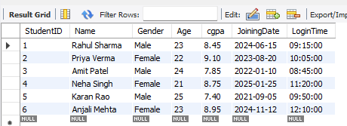
// Inserted all records in the table

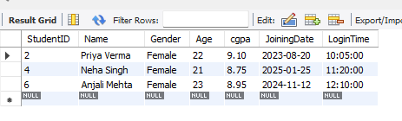
//Display student where gender is female and age less than 24

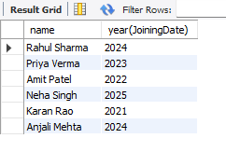
//Display year of joining date //Display current date
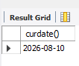

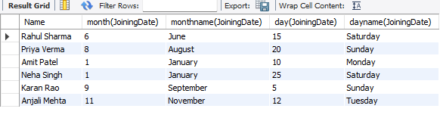
// Display month name , day name, month number and day number

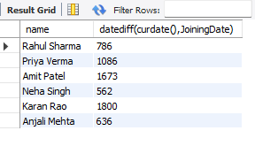
//Display number of days since joining

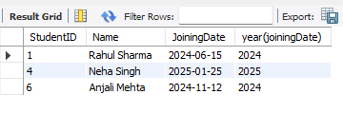
// Display students who joined after 2023-12-31

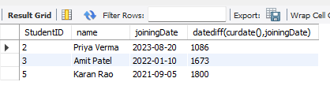
// Display student who joined at least 1000 days before current date

